CE211-L Circuit Analysis Lab



Lab Report # 8

Submitted by: Shayan Rizwan Yazdanie [2024585]
Submitted to: Engr. Muhammad Shakaib
Semester: 03

Faculty of Computer Science and Engineering
GIK Institute of Engineering Sciences and Technology

Task Statement:
- Calculate the total resistance of the given circuit and calculate the loop currents.
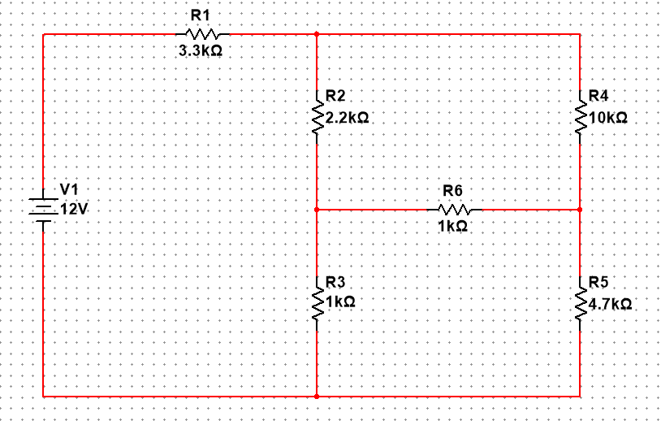

Solution
Parameter | R_{T} (kΩ) | I₁ (mA) | I₂ (mA) | I₃ (mA)
Theoretical | 5.927 | 2.02 | 0.364 | 0.358
Experimental | 5.381 | 2.33 | 0.38 | 0.39
% Error | 10% | 15% | 4.4% | 9.5%

Calculating R₁, R₂ and R₃
R₁​= R_{B​}R_{C}​​ / R_{A}​+R_{B}​+R_{C}​
$$R_{1}=\frac{(4.7k)(1k)}{6.7k} \\ R_{1}=\frac{4.7k^{2}}{6.7k}=701.49Ω$$

R₂​= R_{A​}R_{C}​​ / R_{A}​+R_{B}​+R_{C}​
$$R_{2}=\frac{(1k)(1k)}{6.7k} \\ R_{2}=\frac{1k^{2}}{6.7k}=149.25Ω$$
R₃​= R_{A​}R_{B}​​ / R_{A}​+R_{B}​+R_{C}​
$$R_{3}=\frac{(1k)(4.7k)}{6.7k} \\ R_{3}=\frac{4.7k^{2}}{6.7k}=701.49Ω$$

Adding Adjacent Resistors

For R₂ side:
$$R_{2}+2.2k=149.25+2200=2349.25Ω$$

For R₃ side:
$$R_{3}+10k=701.49+10,000=10,701.49Ω$$Combine These Two in Parallel
$$\frac{1}{R}=\frac{1}{R_{A}}+\frac{1}{R_{B}}$$
$$\frac{1}{R}=\frac{1}{2349.25}+\frac{1}{10701.49}$$
$$\frac{1}{R}=5.1911×{10}^{-4}$$

$$R=\frac{1}{5.1911×{10}^{-4}}=1926.374Ω$$Add Remaining Series Resistors for R_{eq}
$$R_{eq}=1926.374+701.49+3300 \\ R_{eq}=5927.864Ω≈5.927kΩ$$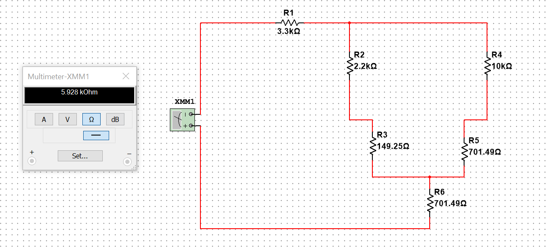

Using Mesh Analysis to calculate loop currents

Loop – 1
$$∑V⋅R=∑V⋅D \\ 12=3.3k I_{1}+2.2k(I_{1}-I_{2})+1k(I_{1}-I_{3})$$
$$12=3.3kI_{1}+2.2kI_{1}-2.2kI_{2}+1kI_{1}-1kI_{3}$$
$$12=6.5kI_{1}-2.2kI_{2}-1kI_{3}$$
$$0.012=6.5I_{1}-2.2I_{2}-I_{3} \\ \boxed{6.5I_{1}-2.2I_{2}-I_{3}=0}-(1)$$

Loop – 2
$$∑V⋅R=∑V⋅D \\ 0=2.2k(I_{2}-I_{1})+10kI_{2}+1k(I_{2}-I_{3})$$
$$0=2.2kI_{2}-2.2kI_{1}+10kI_{2}+1kI_{2}-1kI_{3}$$
$$0=-2.2I_{1}+13.2I_{2}-I_{3}$$
$$\boxed{2.2I_{1}-13.2I_{2}+I_{3}=0}-(2)$$

Loop – 3
$$∑V⋅R=∑V⋅D \\ 0=1k(I_{3}-I_{2})+1k(I_{3}-I_{1})+4.7k(I_{3})$$
$$0=1kI_{3}-1kI_{2}+1kI_{3}-1kI_{1}+4.7kI_{3}$$
$$0=-I_{1}-I_{2}+6.7I_{3}$$
$$\boxed{I_{1}+I_{2}-6.7I_{3}=0}-(3)$$

Final Mesh Currents
$$\boxed{I_{1}=2.023\text{ mA}} \\ \boxed{I_{2}=0.364\text{ mA}} \\ \boxed{I_{3}=0.357\text{ mA}}$$
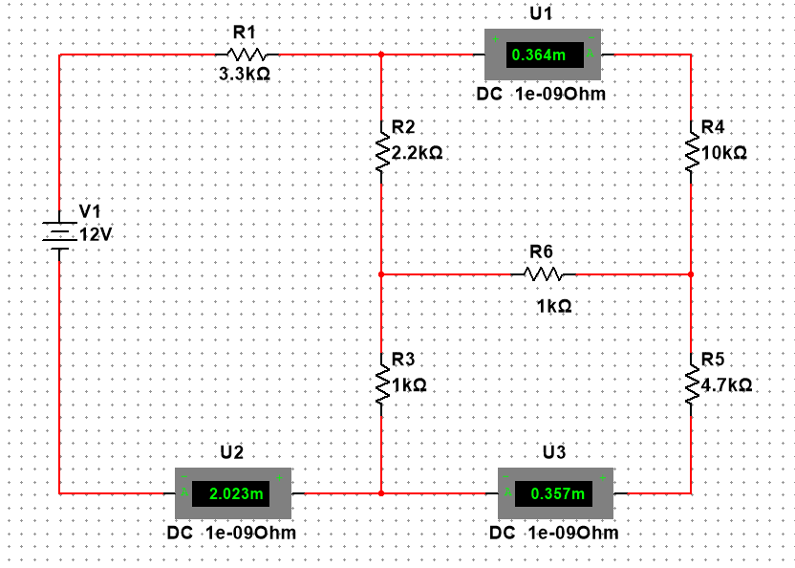

- Calculate the total resistance of the given circuit and calculate all the voltage drops across each resistor.
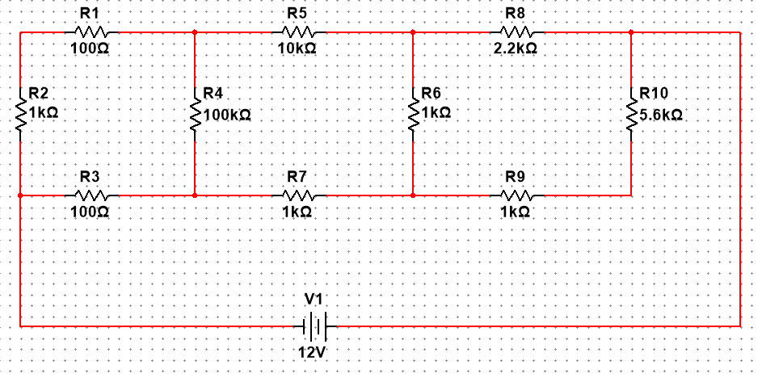
Solution

Resistance
- Left branch (R₁):
$$\text{R1}\text{​}\text{=}\text{100} \text{Ω}\text{+}\text{1000} \text{Ω}\text{+}\text{100} \text{Ω}\text{=}\text{1200} \text{Ω}Ω$$
- Middle branch (R₂):
R2​=10000 Ω+100000 Ω+1000 Ω = 111000 Ω
- Right branch (R₃):
R3​=2200 Ω+1000 Ω+5600 Ω+1000 Ω = 9800 Ω
So, the three branch resistances are:
- $R_{1}=1200 Ω$
- $R_{2}=111000 Ω$
- $R_{3}=9800 Ω$
- Combine the three branch resistances in parallel to get the total equivalent resistance $R_{T}$.
Use:
$$\frac{1}{R_{T}}=\frac{1}{R_{1}}+\frac{1}{R_{2}}+\frac{1}{R_{3}}$$
$$\frac{1}{R_{1}}=\frac{1}{1200}=0.0008333333 1/Ω \\ \frac{1}{R_{2}}=\frac{1}{111000}≈0.0000090090090 1/Ω \\ \frac{1}{R_{3}}=\frac{1}{9800}≈0.0001020408 1/Ω$$
Sum:
$$\frac{1}{R_{T}}=0.0008333333+0.0000090090+0.0001020408=0.0009443831 Ω^{-1}$$
Invert to get $R_{T}$:
$$R_{T}=\frac{1}{0.0009443831}≈1058.892 Ω$$

Voltages
- Branch currents:
$$I_{1}=\frac{V_{s}}{R_{1}}=\frac{12}{1200}=0.01000\text{ A}=10.00\text{ mA} \\ I_{2}=\frac{12}{111000}≈0.0001081081\text{ A}=0.1081081\text{ mA} \\ I_{3}=\frac{12}{9800}≈0.0012244898\text{ A}=1.2244898\text{ mA}$$
- Voltage across each resistor (use V = I_branch × R_each):
Left branch (branch 1, $I_{1}=0.01\text{ A}$):
- V1 (100 Ω top) = $0.01×100=1.00\text{ V}$
- V2 (1 kΩ vertical) = $0.01×1000=10.00\text{ V}$
- V3 (100 Ω bottom) = $0.01×100=1.00\text{ V}$
(Their sum: $1.00+10.00+1.00=12.00\text{ V}$.)
Middle branch (branch 2, $I_{2}≈0.0001081081\text{ A}$):
- V4 (10 kΩ top) = $0.0001081081×10000≈1.0810811\text{ V}$
- V5 (100 kΩ vertical) = $0.0001081081×100000≈10.8108108\text{ V}$
- V6 (1 kΩ bottom) = $0.0001081081×1000≈0.1081081\text{ V}$
(Sum ≈ 12.000000 V.)
Right branch (branch 3, $I_{3}≈0.0012244898\text{ A}$):
- V7 (2.2 kΩ top) = $0.0012244898×2200≈2.6938776\text{ V}$
- V8 (1 kΩ vertical) = $0.0012244898×1000≈1.2244898\text{ V}$
- V9 (5.6 kΩ inner) = $0.0012244898×5600≈6.8571429\text{ V}$
- V10 (1 kΩ bottom) = $0.0012244898×1000≈1.2244898\text{ V}$
(Sum ≈ 12.000000 V.)

Parameter | Theoretical | Experimental | % Error
R_{T} (Ω) | 1058.892 | 1065.0 | 0.577 %
V1 (V) | 1.000 | 0.99 | 1.00 %
V2 (V) | 10.000 | 10.05 | 0.50 %
V3 (V) | 1.000 | 1.01 | 1.00 %
V4 (V) | 1.08108 | 1.08 | 0.10 %
V5 (V) | 10.81081 | 10.75 | 0.56 %
V6 (V) | 0.10811 | 0.11 | 1.75 %
V7 (V) | 2.69388 | 2.70 | 0.23 %
V8 (V) | 1.22449 | 1.23 | 0.45 %
V9 (V) | 6.85714 | 6.85 | 0.10 %
V10 (V) | 1.22449 | 1.22 | 0.37 %

- Calculate the total resistance of the given circuit and calculate all the voltage drops across each resistor.
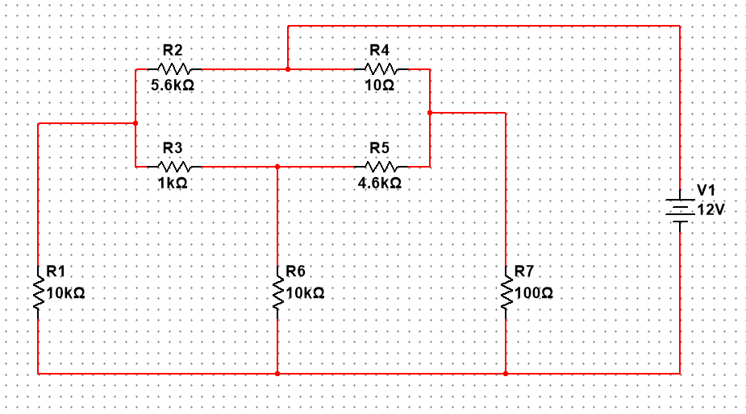
Solution

Resistance

Step A — conductance (S)
$$\begin{matrix}G_{L} & =1/R_{left_v}=1/10000=0.0001000000 S \\ G_{M} & =1/R_{mid_v}=1/10000=0.0001000000 S \\ G_{AB} & =1/R_{top1}+1/R_{mid1}=1/5600+1/1000 \\ & =0.0001785714286+0.0010000000000=0.0011785714286 S \\ G_{BC} & =1/R_{top2}+1/R_{mid2}=1/10+1/4600 \\ & =0.1000000000+0.0002173913043=0.1002173913043 S\end{matrix}$$

Step B — nodal equations (nodes A and B)
Node A (VA):
$$G_{L}V_{A}+G_{AB}(V_{A}-V_{B})=0$$
Node B (VB), with VC = 5 V:
$$G_{M}V_{B}+G_{AB}(V_{B}-V_{A})+G_{BC}(V_{B}-V_{C})=0$$
Substitute numbers and simplify:
(1) $0.0012785714286 V_{A}-0.0011785714286 V_{B}=0$
(2) $-0.0011785714286 V_{A}+0.1014959627329 V_{B}=0.5010869565215$
From (1): $V_{A}=\frac{0.0011785714286}{0.0012785714286}V_{B}=0.9217391304348 V_{B}.$
Substitute into (2) and solve for $V_{B}$:
$$0.1004090062112 V_{B}=0.5010869565215⇒V_{B}≈4.99045 V.$$
Then
$$V_{A}=0.9217391304348×4.99045≈4.60000 V.$$

Step C — Total current drawn from the 5 V source
Currents leaving node C:
- through Rright_v (to ground): $I_{100}=V_{C}/R_{100}=5.000/100=0.050000 A$
- through branch C→B (combined): $I_{C→B}=(V_{C}-V_{B})⋅G_{BC}=(5.000-4.99045)×0.1002173913≈0.000955 A$
Total source current:
$$I_{total}=I_{100}+I_{C→B}≈0.050000+0.000955=0.050955 A.$$

Step D — equivalent resistance
$$R_{T}=\frac{V_{source}}{I_{total}}=5/0.050955≈98.13 Ω$$

Voltages
Voltage across each resistor is the difference of the node voltages at its terminals (V = V(higher node) − V(lower node)).
- V1 = voltage across Rtop1 (5.6 kΩ) between A and B = $V_{A}-V_{B}=4.60000-4.99045=-0.39045$. Magnitude = 0.39045 V.
- V3 = across Rmid1 (1 kΩ) between A and B = same nodes → 0.39045 V.
- V2 = across Rtop2 (10 Ω) between B and C = $V_{B}-V_{C}=4.99045-5.00000=-0.00955 V$. Magnitude = 0.00955 V.
- V4 = across Rmid2 (4.6 kΩ) between B and C = same nodes → 0.00955 V.
- V5 = across Rleft_v (10 kΩ) = $V_{A}-V_{D}=4.60000-0=$4.60000 V.
- V6 = across Rmid_v (10 kΩ) = $V_{B}-0=$4.99045 V.
- V7 = across Rright_v (100 Ω) = $V_{C}-0=$5.00000 V.
$I_{100}=5/100=0.0500$A
$I_{left_v}=4.6/10000=0.00046$A $I_{mid_v}=4.99045/10000=0.00049905$A
Parameter | RT (Ω) | V1 (V) | V2 (V) | V3 (V) | V4 (V) | V5 (V) | V6 (V) | V7 (V)
Theoretical | 98.13 | 0.39045 | 0.00955 | 0.39045 | 0.00955 | 4.60000 | 4.99045 | 5.00000
Experimental | 99.5 | 0.382 | 0.00980 | 0.387 | 0.00940 | 4.570 | 4.955 | 4.985
% Error | 1.40% | 2.16% | 2.62% | 0.88% | 1.57% | 0.65% | 0.71% | 0.30%

